Python Basic Assignment

In [1]:

1. Write a Python program to print "Hello Python"?

print("Hello Python")

Hello Python

In [2]:

1. Write a Python program to do arithmetical operations addition and division.?
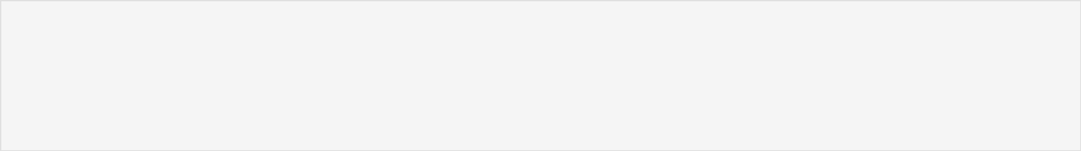

a = 10

b = 5

# Addition

result_add = a + b

print("Addition:", result_add)

# Division

result_div = a / b

print("Division:", result_div)

Addition: 15

Division: 2.0

In [3]:

1. Write a Python program to find the area of a triangle?
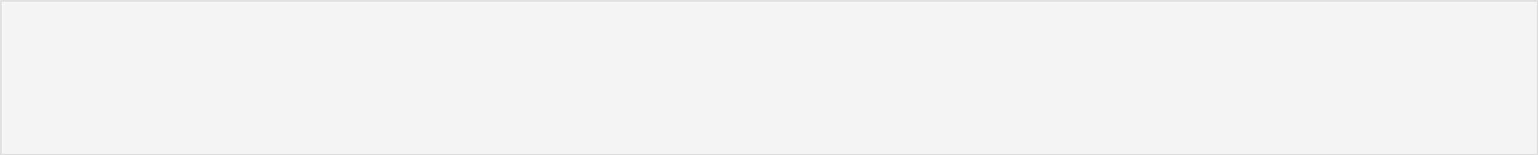

base = 10

height = 5

- Calculate the area of a triangle area = 0.5 * base * height

print("Area of the triangle is:", area)

Area of the triangle is: 25.0

1. Write a Python program to swap two variables?
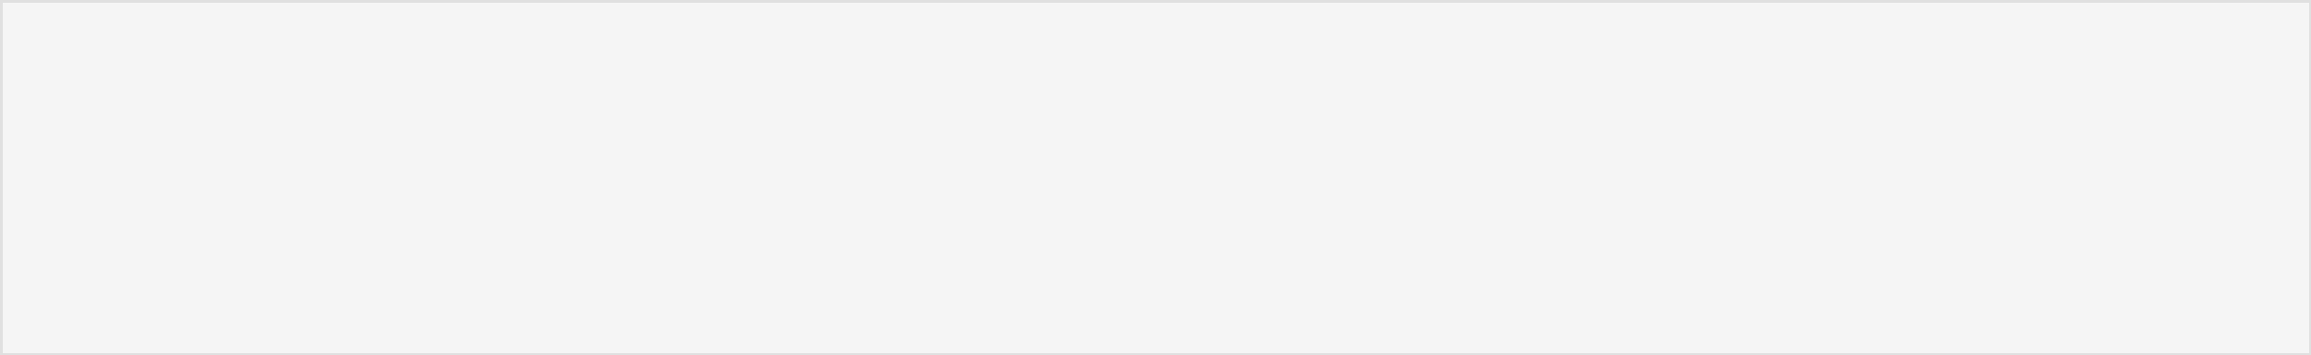

In [4]:

a = 5

b = 10

print("Before swapping: a =", a, "and b =", b)

- Swap the values temp = a

a = b

b = temp

print("After swapping: a =", a, "and b =", b)

Before swapping: a = 5 and b = 10

After swapping: a = 10 and b = 5

In [5]:

1. Write a Python program to generate a random number?

import random

- Generate a random number between 1 and 10 random_num = random.randint(1, 10)

print("Random number:", random_num)

Random number: 10

In [ ]:

